Task :4
VCS Task

Establish a new directory, populate it with script files, initiate an empty repository on GitHub, convert the local directory into a Git repository, and link it to GitHub for pushing the code into the repository.Perform merge, rebase, stash commands in following github repo.

Created a local directory into a git repo.

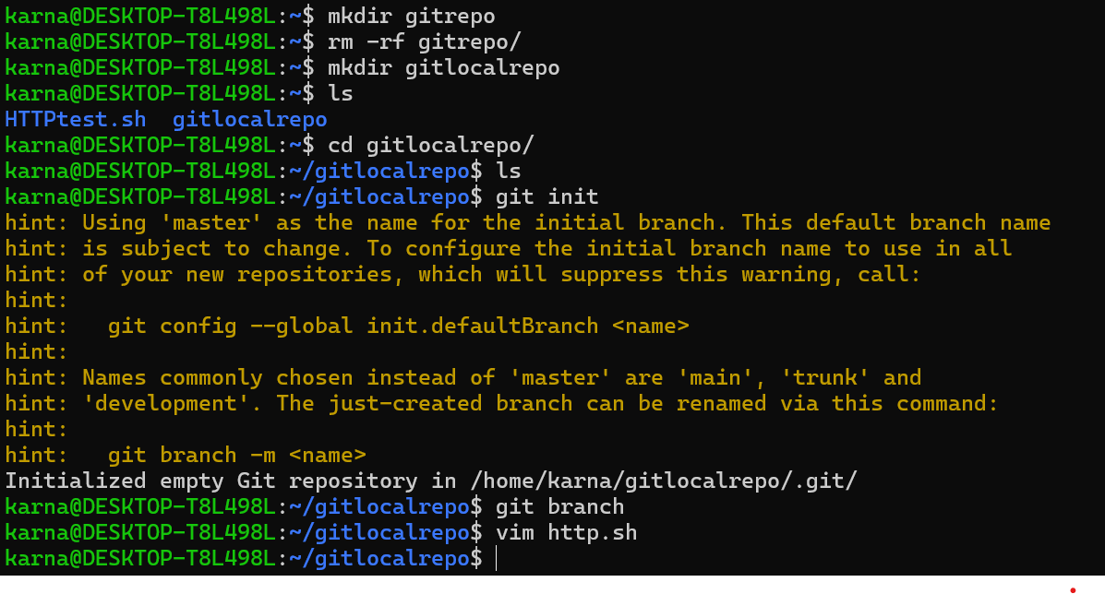
link the GitHub for pushing the code into the repository

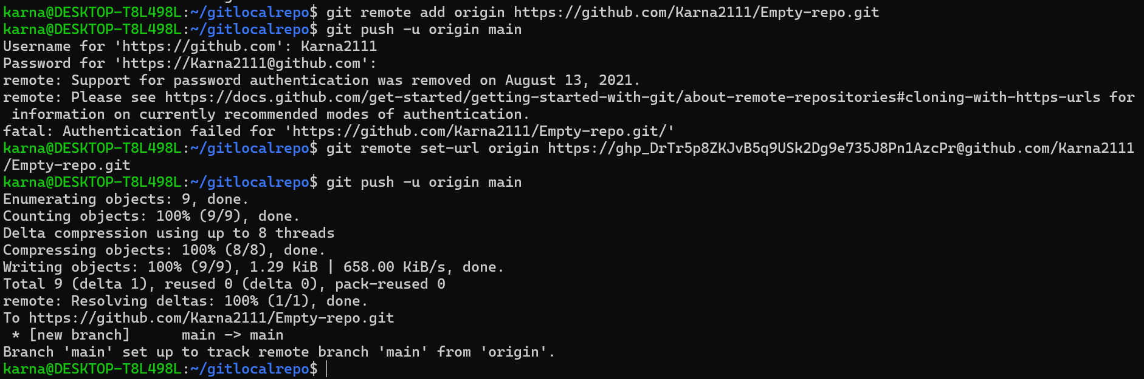
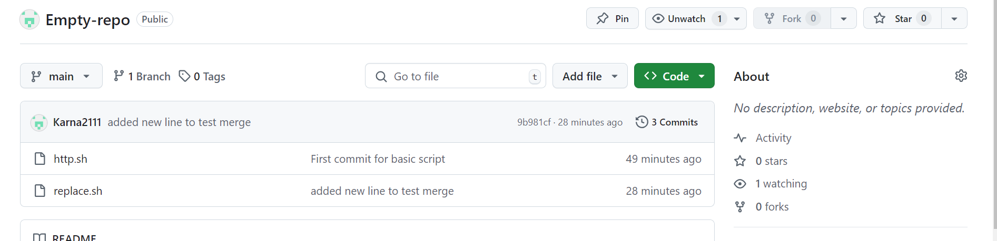

Performing merge,
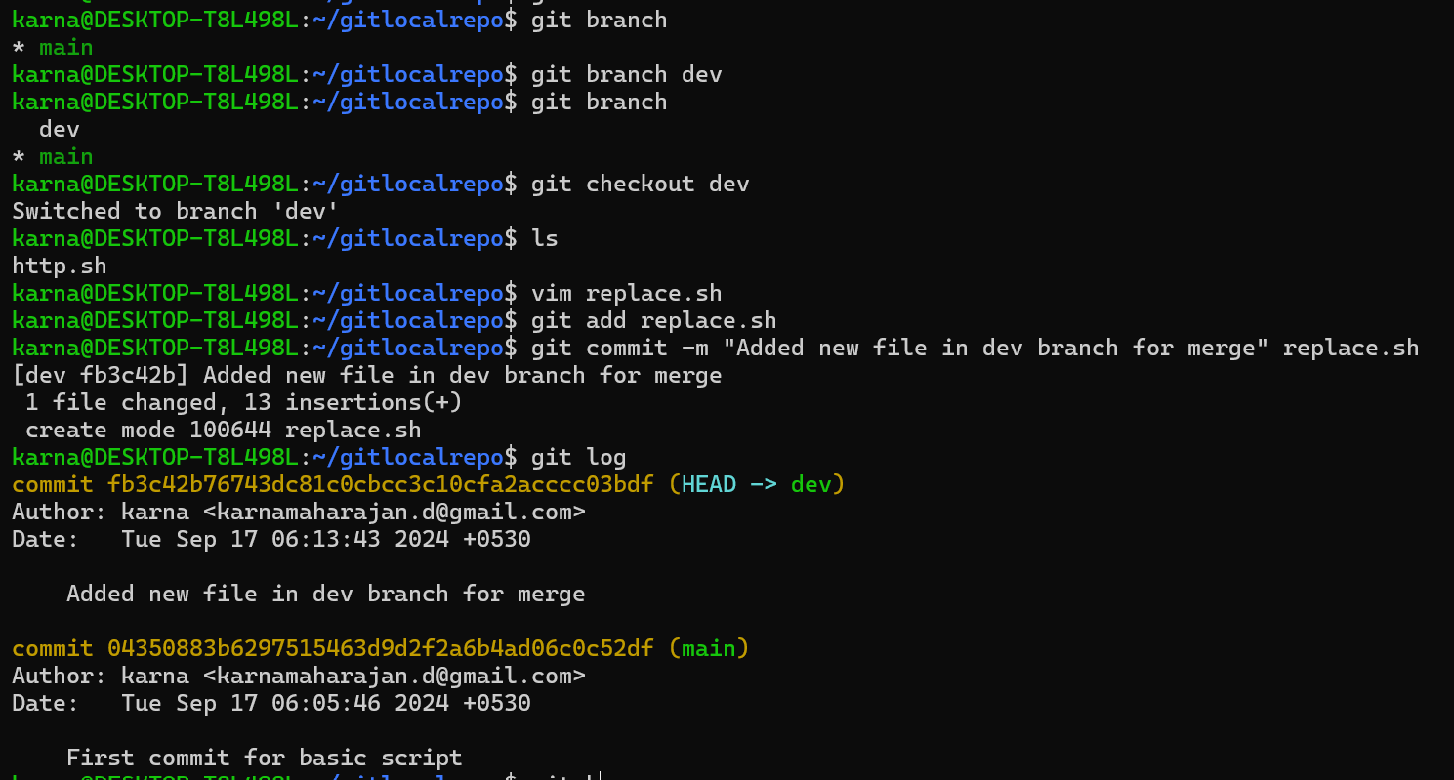

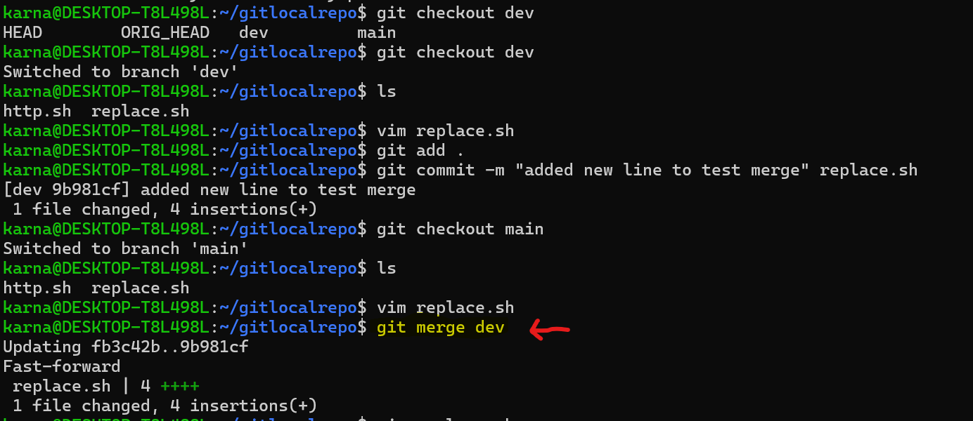

GIT stash

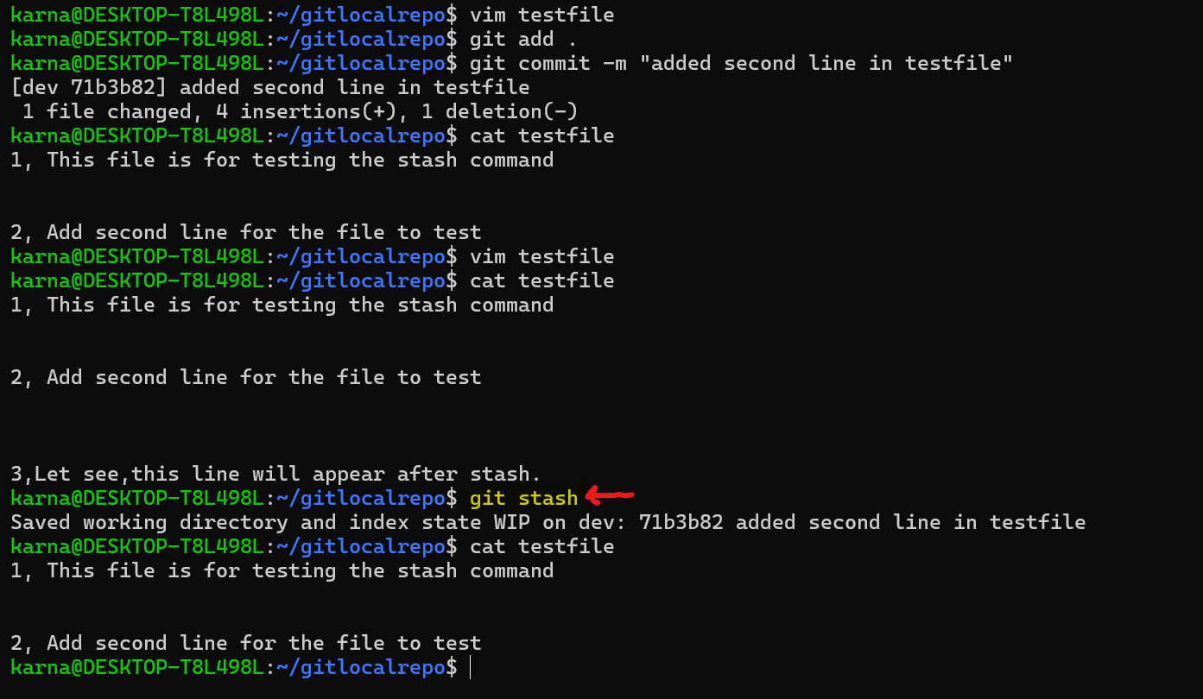

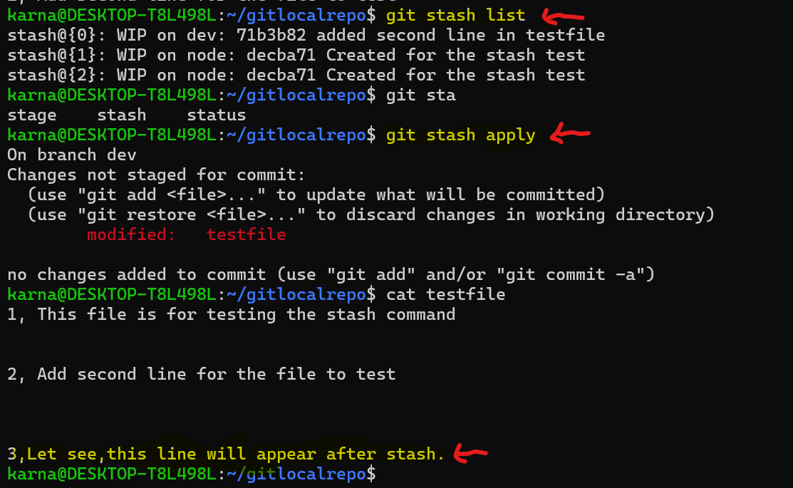

Git rebase



                                                           

